**Problem statement:**

Create an application that will, given a UK currency amount and the purchase price of a product, display the change to be returned split down by denomination, largest first.

***Example:***

Given £20 and a product price of £5.50, the application will output:

Your change is:

1 x £10

2 x £2

1 x 50p

**Solution:**

**GitHub -** [**Anil-Lakhagoudar/ExperianDevTestDenominationCalculator (github.com)**](https://github.com/Anil-Lakhagoudar/ExperianDevTestDenominationCalculator)

Console application is developed using .NET6 framework and integrated with NUnit testing framework for unit testing.

<https://github.com/Anil-Lakhagoudar/ExperianDevTestDenominationCalculator/blob/main/README.md>

Screen –

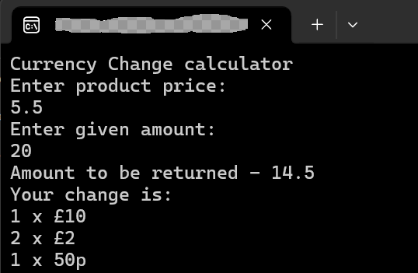

Attached executable file for reference and run the exe from the release folder, system should have .NET installed.

